**DSA Assignment – 17th July**

**Name – Karan Joshi**

**Roll No. – 23/11/EC/036**

**Leetcode Id – Karan_Joshi068048**

**Geeksforgeeks Id – wwwjoshikaran3424**

**Github Repo Link -** [**https://github.com/KaranJoshi101/urban-octo-robot/**](https://github.com/KaranJoshi101/urban-octo-robot/)

DSA-Section -

Question 1: LCA in Binary Tree

Submission Screenshot:

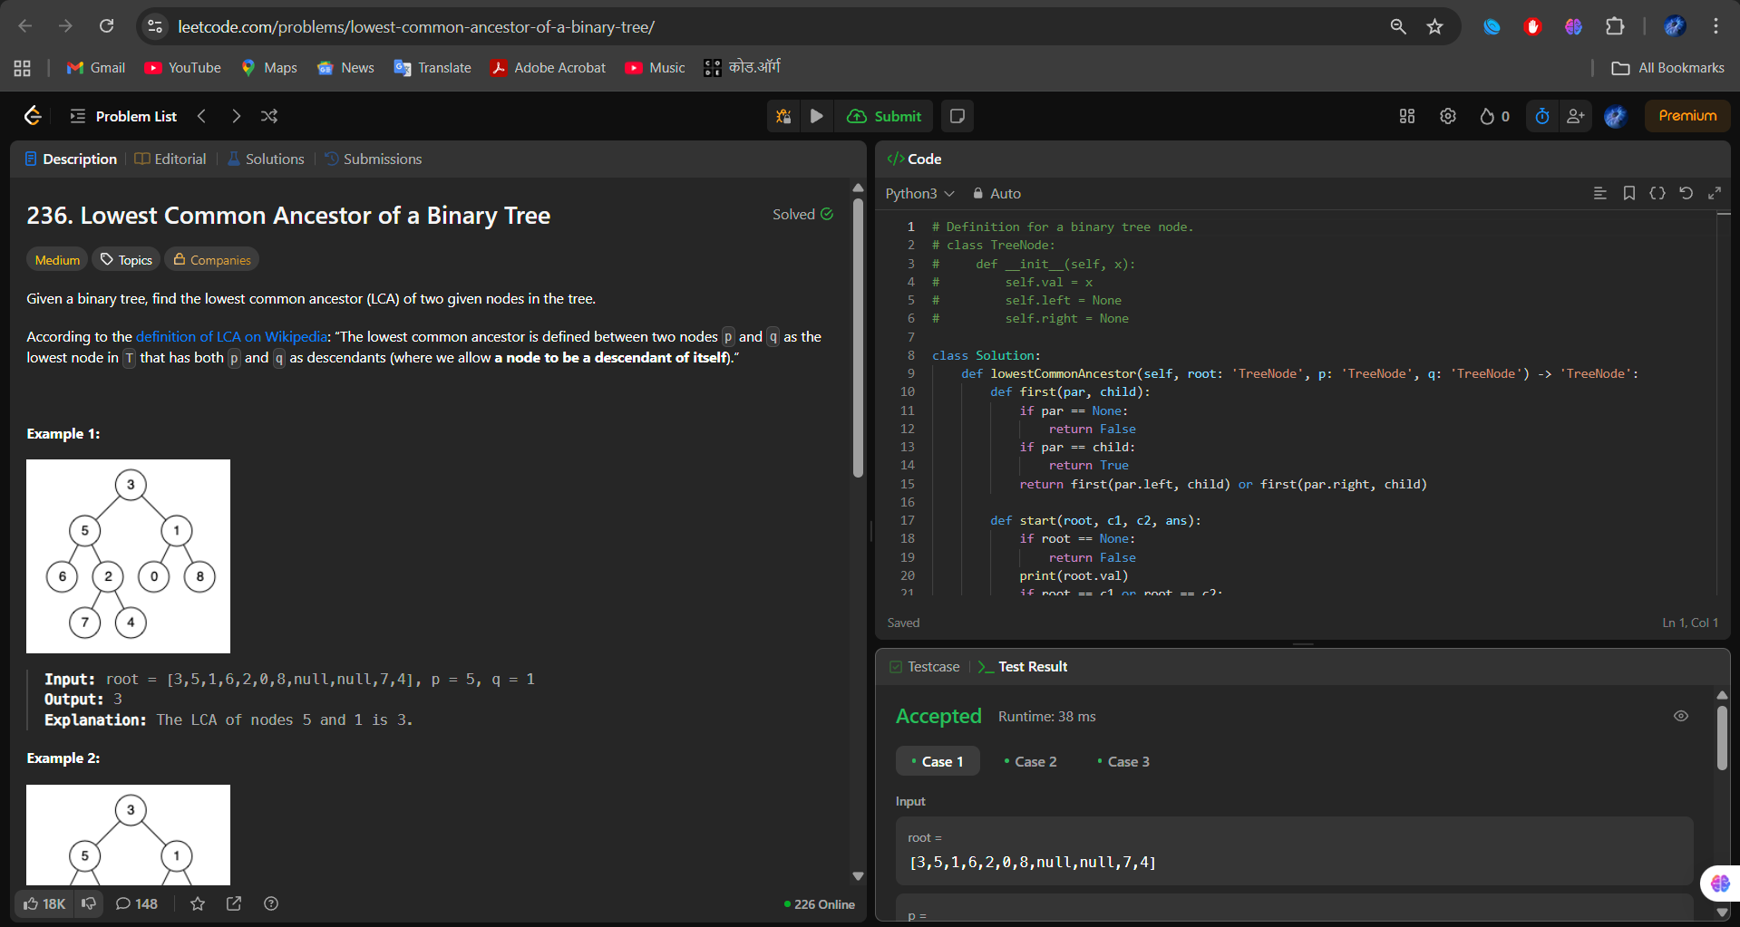

Question 2: Time to be Infected in Binary Tree

Submission Screenshot:

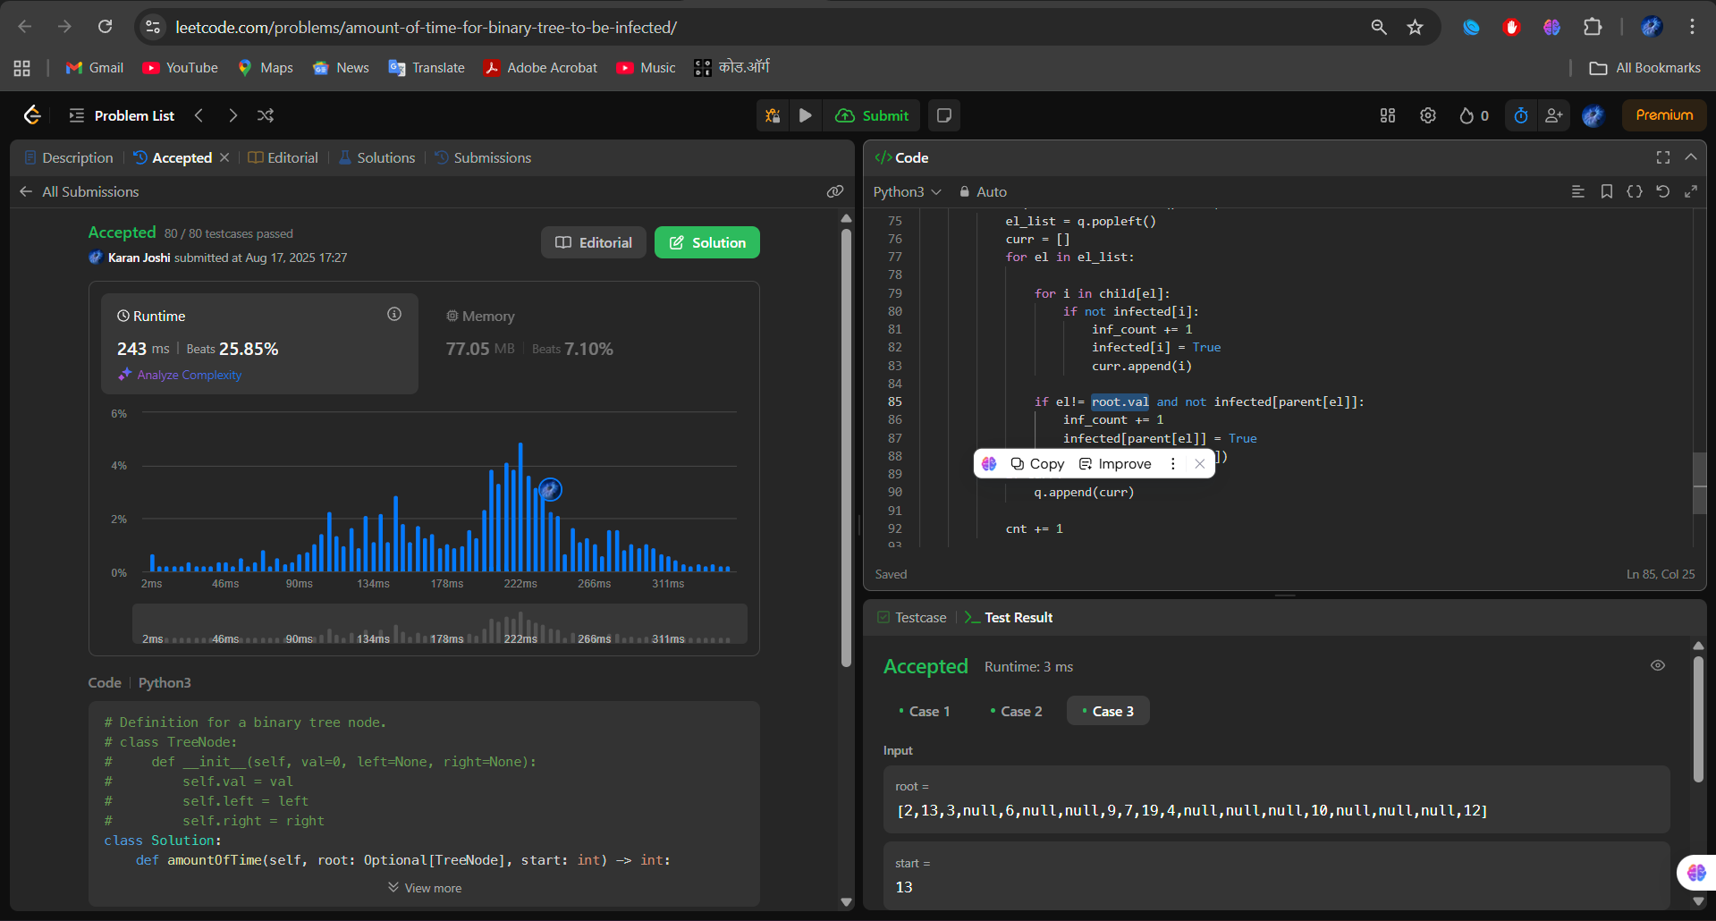

Question 3: Count Nodes in Complete Tree

Submission Screenshot:

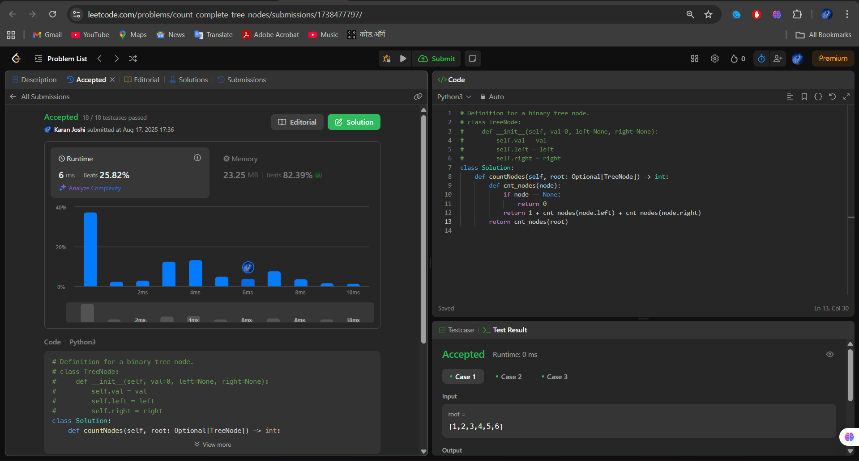

Question 4: Validate BST

Submission Screenshot:

